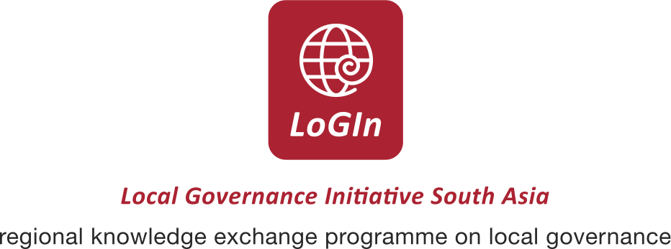

Good Practices Workshop

As a first step towards promoting an exchange of experiences, SDC’s Local Governance Initiative South Asia (LoGIn) organised a Workshop on ‘Good Practices in strengthening Decentralisation’ on 24th and 25th August 2009 in New Delhi.

The objectives of the workshop were (i) to promote exchange of experiences in a particular area relating to strengthening decentralisation, (ii) to develop criteria for assessing good practices in strengthening decentralisation and, (iii) to select good practices from the experiences shared in the workshop for the purpose of documenting and then to share with a wider range of stakeholders.

The workshop was attended by 11 partner organisations of SDC. Each organisation presented a specific practice which then was discussed by the other participants as well as vetted by a panel of eminent discussants who, through their comments and feedback have attempted to (i) sharpen the analysis of the experience being shared so as to identify the good practice and (ii) contribute towards identifying criteria for assessing good practices.

The proceedings of the workshop will be available on this website shortly. For more information please contact Ms. Priya Chawla: Priya.chawla@sdc.net

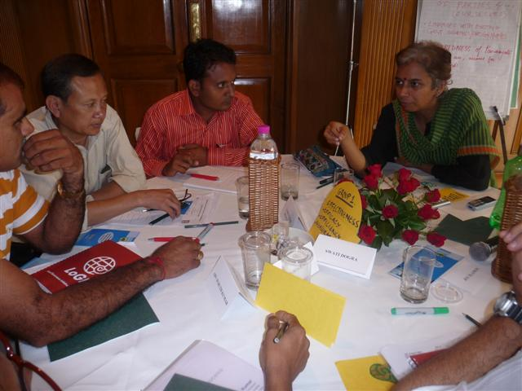

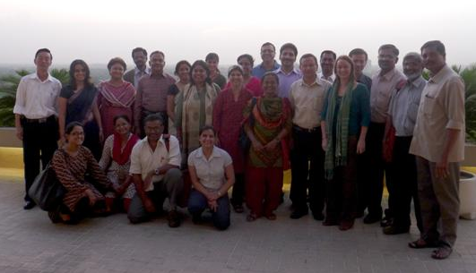

Programme for the Good Practices Workshop
Day 1
24th August 2009
Time | Topic | Organisation
0930 1030 | Welcome and Opening Note  Introductions | SDC
1030 1130 | Pre Election Voters Awareness Campaign (PEVAC) | PRIA and Sahbhagi Shikshan Kendra
1130 1230 | Federating locally elected women representatives at the State Level | Mahila Rajsatta Andolan & RSCD
1230 1330 | Federating locally elected women representatives at the District Level | Kachch Mahila Vikas Sangathan
1330 1400 | Discussants’ Feedback on the morning session Presentations | Panel of Discussants
1400 1500 | Lunch
1500 1600 | Strengthening Gram Panchayats to integrate disaster preparedness in village level micro planning | The Hunger Project
1600 1700 | Strengthening Gram Panchayats through provisioning of untied Village Development Funds. | Kachch Nav Nirman Abhiyan
1700 1800 | Decentralised Training Provisioning for elected representatives and frontline functionaries | IGPR & GVS
1800 1830 | Discussants’ Feedback on the Presentations made in the Post lunch session | Panel of Discussants

Day 2
25th August 2009
Time | Topic | Organisation
0900 0930 | Review of previous day/ Other Announcements | SDC
0930 1030 | Strengthening capacities of Gram Panchayats for habitation level planning and integrated Village Development Planning | Intercooperation
1030 1130 | Democratizing participation  below the Gram Panchayat through the setting up and empowerment of Standing  Committees. | Melli Dhera Gram Panchayat Unit, South Sikkim
1130 1230 | Strengthening administrative and governance systems of Gram Panchayats | Grameen Padana Kendram
1230 1300 | Discussants’ Feedback on the morning session Presentations | Panel of Discussants
1300 1400 | Lunch
1400 1500 | Strengthening Gram Panchayats to take up natural resource management and conservation and development of sustainable habitat norms | Maithri
1500 1600 | Organising and streamlining the functioning of Jaagratha Samithis in Gram Panchayats | Centre for Rural Management
1600 1630 | Discussants’ Feedback on the Presentations made in the Post lunch session | Plenary
1630 1730 | Open Session & Next Steps | Plenary

List of Participants

SN | Name | Organisation | State/ City
1 | Dr. Jos Chathukulam | Centre for Rural Management | Kerela
2 | Mr. Vinod Kumar | Maithri | Kerela
3 | Ms. Mariamma Sanu George (Nirmala) | CapDeck | Kerela
4 | Mr. Suruth Kumar | Grameen Padana Kendram | Kerela
5 | Prof. Anita | IGPR & GVS | Jaipur
6 | Mr. Giri Raj Singh | IGPR & GVS | Jaipur
7 | Mr. Bhim Raskar | Mahila Rajsatta Andolan & RSCD | Mumbai
8 | Mr. S. S. Meenakshisundaram | Myrada | Bangalore
9 | Mr. Ganesh Rai | Melli Dhera Gram Panchayat Unit, South Sikkim | Sikkim
10 | Mr. D.T.Bhutia | State Institute for Rural Development | Sikkim
11 | Mr. Tashi W. Khangsarpa | Indo Swiss Project, Sikkim | Sikkim
12 | Ms. Sushma Iyenger | Kachch Nav Nirmaan Abhiyaan | Gujrat
13 | Ms. Shalini Chaturvedi | Sahbhagi Shikshan Kendra | Lucknow
14 | Ms. Sheetal Patel | Setu | Gujrat
15 | Mr. Vikram Solanki | Setu | Gujrat
16 | Mr. Bhavasinh Kher | Setu | Gujrat
17 | Mr. Devanshu Chakravarti | Intercooperation | Secunderabad (AP)
18 | Ms. Lata Sachde | Kachch Mahila Vikas Sangathan | Gujrat
19 | Ms. Meenu Vadera | Azad Foundation | Delhi
20 | Ms. Sriparna Chaudhary | The Hunger Project | Delhi
21 | Ms. Tina Mathur | Solution Exchange (UNDP) | Delhi
22 | Dr. Joy Elamon | Solution Exchange (UNDP) | Delhi
23 | Mr. Manoj Rai | PRIA | Delhi
24 | Mr. Adil Ali | Consultant | Delhi
25 | Ms. Swati Dogra | Consultant | Delhi
26 | Ms. Preeta Lall | LoGIn (Hub) | Delhi
27 | Ms. Sonya Elmer | LoGIn (Hub) | Delhi
28 | Ms. Anne Bernhard | LoGIn (Hub) | Delhi
29 | Ms. Priya Chawla | LoGIn (Hub) (Organisation of Workshop) | Delhi

